Fetter Fitness and Spinal Health
Congratulations on making a decision to improve your health and wellbeing.
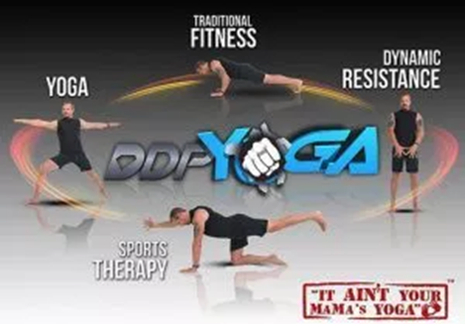
DDPYoga is developed by former professional wrestler Diamond Dallas Page. He originally developed DDPY for athletes that have had years of injuries. He ruptured his L4 and L5 spinal discs at the peak of his career and was desperate to keep wrestling so was willing to try anything, including yoga. He started mixing it with other fitness and rehab and the results were so great he developed and refined DDPY, and started teaching it to others. He also found that very deconditioned people could do DDPY, and many have lost 100s of pounds as a really awesome side effect.
What is DDPY - DDPY is a combination of traditional yoga positions, old-school calisthenics, sports rehabilitation therapy principles, and Dynamic resistance. Dynamic Resistance teaches you how to engage muscles during every aspect of the workout by slowing down, resisting, or pressing against each move. This combination gives you and aerobic low-impact workout and adds strength and endurance to everything you do. You’ll strengthen your core, increase flexibility, turn fat into lean muscle and increase your heart rate.
The goal of DDPY is to help you become and healthier person and unlock the secret to staying youthful for life.
Mindset – Embracing an active lifestyle is essential to your mental and physical health. What are you hoping to achieve from DDPYoga? Is it to reduce back pain, lose weight, improve flexibility, gain muscle, keep up with the grandkids etc. Whatever your reason, write it down and keep it visible.
Breathing – Learning how to breathe is one of the most important principles in DDPY. Your muscles need oxygen to convert glucose into energy. In any workout, controlling you breathe makes your workout easier and helps breakdown stored fat and convert it to high octane fuel. We practice diaphragmatic breathing. As you inhale, fill your stomach/ diaphragm with air until it blows up like a balloon. Then take a long exhale and push the air out as you press your bellybutton to the back of your spine. Each breathe fuels your muscles and helps you push through each move for maximum benefit.
Heart rate - Most of us think the harder we work the better the results…. not true when it comes to exercise. Working smarter is more important. Wearing a heartrate monitor will let you know exactly how much effort you need to burn fat. Calculating your fat burning zone is simple. Subtract your age from 180. This is the top of your range. Then subtract another 20. This is the bottom of your range.
Eg for a 40 year old. 180-40 = 140 140-20 = 120 Fat burning zone is 140-120 beats per minute. You can monitor this using devices such as fitbit etc, to link with the app you need a Bluetooth monitor or apple watch.
Tracking Progress – If you really want to succeed, you need to set a goal and track your progress. Each week, or month, write down something that has become easier, or a change you have noticed. Can you climb stairs without getting winded? Can you get through a workday with less pain? Do you clothes fit differently?
Progress photos are a great way to see changes. They are a visual indicator of progress you have made and can keep you motivated and inspired in yourself and your abilities. We encourage you to take the following 6 photos. These are for you, they don’t have to be shared. Many people are hesitant to take these at first, but those that have missed them really wished they had. Even if you don’t want to look at them, file them away for later… DO IT!!
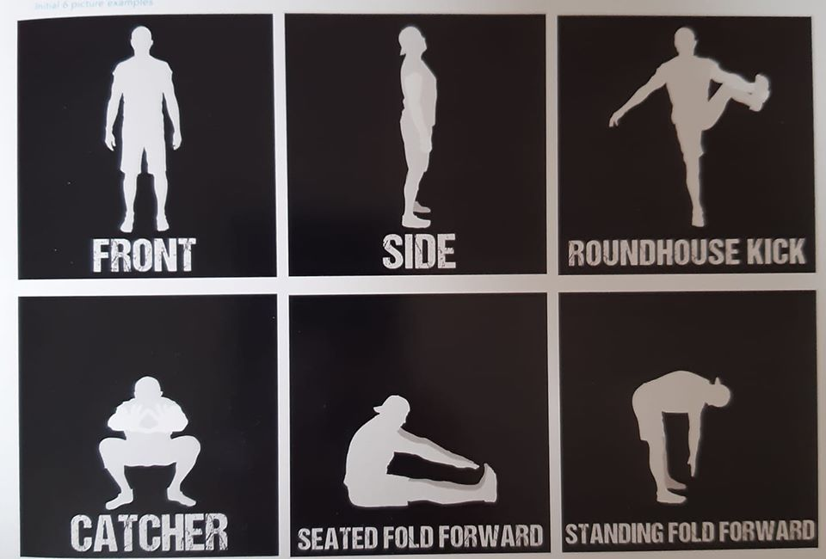
The easiest way to monitor your progress is through the FREE DDP YOGA NOW app. You don’t need to have a paid subscription. You can take and store your photos and measurements for free.

Modifications – MAKE THE WORKOUT YOUR OWN!! You will hear this a lot!! The options to modify to suit your needs sets DDPY apart from many other fitness systems and allows for a wide range of people to participate and get amazing results. If you have injuries or problem areas, modifications are essential. You can use a chair, lower to a knee, stop engaging, step in or lower to safety zone at any time. IT’S OK!! Each day you get a little stronger and flexible.
We can’t guarantee results and check with your doctor if you have any concerns. The workouts are designed so they don’t include running, jumping or lifting which often cause most of the problems, BUT, use your own judgment and listen to your body, discomfort is good, pain is not!!
Nutrition – To get the most from your workouts nutrition should be considered. The more you investigate and educate yourself about food and diet the better and more informed choices you can make. DDPY does not include a “diet”, these fail over and over. It is about making lifestyle choices, and understanding why those changes are important to keep your body nourished and fuelled. The DDPY program recommends Organic foods when available or affordable, Dairy free, and Gluten Free. Phase one is to start removing highly processed convenience foods such as soft drinks, chips, biscuits etc and adding more fresh fruit and vegetables. Phase Two removing wheat and Dairy. Phase Three Organic foods and adding in principles of food combining.
This is a short overview of the program. If you would like more information about the app or any other aspect please ask. There is lots of information and support online using the website or social media pages.

Its time to believe in YOURSELF, and believe in what DDPY can do for you – if you put in the work.

I am honoured to be part of YOUR journey.

Dr Abbie

